OMI weekly news update
FREE workshop for women of migrant backgrounds
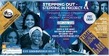
The Aus-Professional-Bridge (APB) designed this workshop to support and inform women from migrant backgrounds in WA.
Date: 12.30 to 3.30pm Saturday 20 July 2019
Venue: Lyal Richardson Hall
The Agonis, 2232 Albany Hwy, GOSNELLS
The project focuses on learning about employment and community participation to help migrant women settle successfully in Western Australia.
More information and registration.

Opportunity for Indonesian women to be involved in a project on women's health
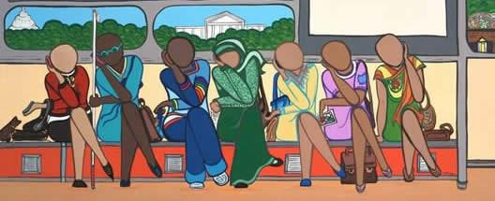
Curtin University's School of Public Health is running a project to design an intervention to improve health service access for Indonesian women living in Perth.
The project is calling for unmarried Indonesian women to participate in a 1.5 hour discussion session scheduled at 10.30am Saturday 27 July 2019.
The information will help to create a program to encourage accessing health services.
For more information and registration, please contact Corie on 9266 4739 or email corie.gray@curtin.edu.au

Let's Talk Culture seminar: Drugs and alcohol in CaLD communities
The Drugs and alcohol in CaLD communities event is presented by the Ishar Multicultural Women's Health Services.
The seminar includes a panel-based discussion on drug and alcohol use and misuses in culturally and linguistically diverse (CaLD) communities.
Date: 9.00 to 11.00am Thursday 8 August 2019
Venue: Department of Health Theatrette
189 Royal Street, EAST PERTH
Let's Talk Culture supports culturally sensitive approaches to working in mental health.
More information and registration.

Inspire Me — Computer skills for job search and career guidance
Multicultural Futures offers free computer courses to eligible refugees and migrants who arrived in Australia in the past five years.
For enquires or registration, please contact Teresa Zemek Employability Skills on
9494 3782 or email teresa.z@multiculturalfutures.org.au
More information about date and location.

You’re Hired workshop for young people
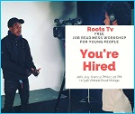
Finding it hard to get that first job? Need help understanding the job market? Don’t know how to build a winning resume?
Roots TV will be running a free youth job readiness workshop to help build your confidence, and job searching and interview skills.
Topics:
- post-it exercise — what do you want out of this workshop?
- assessment of individual skills and requirements
- how to search and plan for jobs
- writing a winning resume
- interview skills
- how to build confidence.
To register visit Roots TV Facebook page.

Click on the links below for more valuable information and opportunities for multicultural communities in WA:
- Job opportunity — Save the Children
- Are your rules and regulations in line with the Associations Act?
- Free resume writing workshop — City of Belmont
- Have your say on the future of road safety
- In Your Head — Youth mental health forum, 5 September 2019
Share your migration story
Some of the events on the OMI calendar this week:
- School holiday program — MMRC
Sur-O-Dhwoni — Bengali Association flag-ship function

WA's amazing cultural diversity is right on your doorstep — check out the
OMI Calendar to find out more.

WA's amazing cultural diversity is right on your doorstep — check out the OMI Calendar to find out more.

