Accreditation –Whistleblower legislation comes into effect 1 January 2020.
While this may not affect every not-for-profit organisation the following information from the Institute of Company Directors and Our Community is timely reminder of the governance obligations of Boards, Management Committees and organisations in general. The article is simple to navigate and the policy and procedure templates provided cover all aspects of the legislation in simple clear terms. The linked policy and procedure whilst not mandatory for Associations is simply good/better/best governance.
your organisation impacted by changes in national whistleblowing statute?
Whistleblowing plays a crucial role in managing risk and cultivating an ethical culture in a not-for-profit organisation.
During 2019, national whistleblowing statue was adopted and from January 1, 2020, some not-for-profits will be required by law to have a whistleblower policy in place.
You can learn more about these statutory changes on page 33 of the latest edition of Our Community Matters.

Who is impacted by these changes?
The Australian Securities and Investments Commission (ASIC) has recently published guidance that will help you understand your obligations. We've broken it down simply for you:
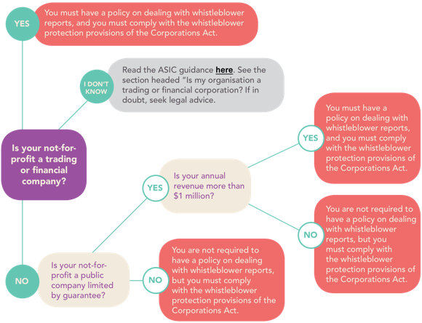
If your organisation has a whistleblower policy already but it was drafted before November 2019, you should review it before January 1 2020 to ensure it takes ASIC's guidance into account.
Even if the law doesn't insist on it, there's no reason to not have a robust whistleblowing policy in place.

We've done the legwork for you
We understand the impact these kinds of changes can have, and we've worked with our trusted partner Moores to draft a whistleblower policy that is fit-for-purpose for most not-for-profit organisations*.
The drafting of this kind of policy would normally cost $2,000 - $4,000. We thank Moores for their pro-bono contribution, and for giving back to the not-for-profit sector.
Download your free whistleblower policy here

Using the template
Please note that this is a template policy for guidance only. For assistance in tailoring this policy to suit your organisation, or for legal advice at a pre-agreed price or training in this area, please contact Moores. They are Our Community's preferred legal supplier and know this policy inside and out.
You can reach them on (03) 9843 2119 or by emailing NFPassist@moores.com.au.
Kind regards,
The Institute of Community Directors Australia team
P.S. If you appreciate this free policy, we'd appreciate your ongoing support by joining Our Community's Institute of Community Directors Australia from only $65 (inc GST) p.a. Read about the benefits of membership here.

