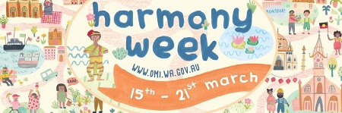
Community groups and not-for-profit organisations are now invited to apply for grants to support Harmony Week 2020.
The Department of Local Government, Sport and Cultural Industries is offering funding of $2000 for diversity and inclusion activities to celebrate Harmony Week in 2020.
Harmony Week, a WA State Government initiative, runs from 15–21 March every year and is an opportunity for everyone to experience, explore and appreciate WA’s wealth of cultural, faith, linguistic and ethnic diversity.
This year, activities that focus on culture and arts and sport and recreation are encouraged.
More information, including guidelines and application form, is available on the OMI website.
Applications close at 4.00pm Monday 21 October 2019.

Preparing for your application
If you would like further advice on the application process, you can register to meet with OMI for a 45-minute one-on-one meeting on one of the following days:
Date: 11.00am to 6.00pm Wednesday 18 September 2019
Venue: Ellenbrook Library — Cafe Room, 90 Main Street, ELLENBROOK
Date: 10.00am to 4.00pm Friday 20 September 2019
Venue: Riverton Library — Studio, 67 Riley Road, RIVERTON
Registration is essential and places are limited.
To register, please email harmony@omi.wa.gov.au with your contact details and the most convenient time for you to attend a 45 minute session.
If you are unable to attend any session on either of these days, OMI staff are able to meet at a time and location more suitable for you.

