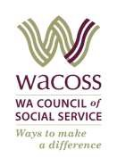
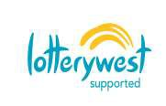
AGENDA
Community Relief and Resilience Forum
5 June 2019
Time 9.30 am to 11.30 am
Conference Room 7, City West Lotteries House, 2 Delhi Street West Perth. Phone: 9420 7222

WACOSS acknowledges the traditional owners of country throughout Western Australia and recognises their continuing connection to land, waters and community. We pay our respect to them and their cultures; and to elders both past and present.

Ngala kaaditj Wadjuk moort keyen kaadak nidja boodja – We acknowledge Noongar people as the original custodians of the land on which our office sits.

Welcome (9.30) | Introductions and acknowledgment
Guest presentation  (9.35)  (10:05) | Lianne Sylvester Attach Specialist Team Leader UnitingCare West  Donna Self Social Reinvestment WA – Lived Experience Story Telling
Break (10.35) | Morning Tea
Items ongoing from action register  (10:45) | - CRR Forum to be hosted at St Vincent De Paul (one off) July meeting  - Child Hospitalization & carer’s payments  - Make Smoking History Professional Development opportunities
Roundtable  (11:00) | Forum attendees’ updates
WACOSS Update  (11:20) | - Food Relief Framework  - CRR and FRF integration  - CRR & FCAWA Conference
Item 8 – New business (11.25)
Next Forum | 9.30am – 11.30am Wednesday, 3 July 2019

